# Twitter Sentiment Analysis Project Documentation

**Project Overview:**

Twitter Sentiment Analysis is a data analytics project that involves analyzing a dataset of tweets to determine the sentiment expressed in each tweet—whether it is positive, negative, or neutral. The project aims to gain insights into public opinions, trends, and sentiments shared on Twitter, utilizing data analytics techniques.

**Dataset:**

The dataset utilized for this project is obtained from [Kaggle](https://www.kaggle.com/datasets/kazanova/sentiment140). It comprises tweets labeled with sentiment values (0 for negative, 2 for neutral, 4 for positive).

**Project Objectives:**

**1. Data Exploration:**

- Explore the Sentiment dataset to understand its structure, features, and size.

- Identify key variables such as tweet content, timestamp, and sentiment labels.

**2. Data Cleaning:**

- Perform data cleaning tasks to handle missing values, duplicate entries, and irrelevant information.

- Ensure data quality by addressing any anomalies or inconsistencies in the dataset.

**3. Exploratory Data Analysis (EDA):**

- Conduct exploratory data analysis to gain initial insights into tweet patterns, sentiment distributions, and temporal trends.

- Utilize visualizations (e.g., histograms, word clouds) to represent key aspects of the dataset.

**4. Sentiment Distribution:**

- Visualize the distribution of sentiment labels (positive, negative, neutral) in the dataset.

- Analyze the balance of sentiment classes to understand potential biases.

**5. Word Frequency Analysis:**

- Analyze the frequency of words in tweets to identify common terms and themes.

- Create word clouds or bar charts to visualize the most frequent words in positive and negative sentiments.

**6. Temporal Analysis:**

- Explore how sentiment varies over time by analyzing tweet timestamps.

- Identify patterns, peaks, or trends in sentiment within specific time frames.

**7. Text Preprocessing:**

- Preprocess tweet text by removing stop words, special characters, and URLs.

- Tokenize and lemmatize words to prepare the text for sentiment analysis.

**8. Sentiment Prediction Model:**

- Implement a sentiment prediction model using machine learning or natural language processing techniques.

- Train the model on a subset of the dataset and evaluate its performance using metrics like accuracy and F1 score.

**9. Feature Importance:**

- Identify the most important features (words or phrases) contributing to sentiment predictions.

- Visualize feature importance using techniques such as bar charts or word clouds.

**Detailed Steps:**

**Data Exploration:**

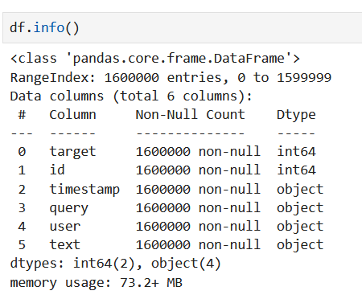Explored the dataset structure and size.

Identified key variables: tweet content, timestamp, and sentiment labels.

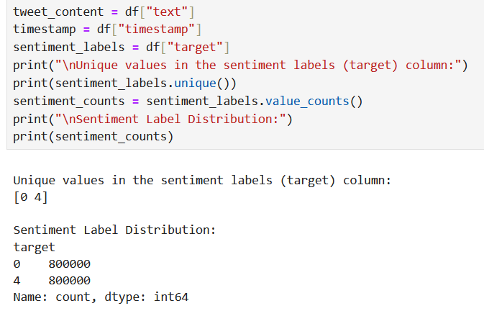

Checked for missing values, duplicates, and irrelevant information.

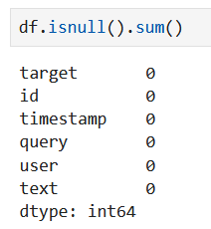

**Data Preprocessing:**

Handled missing values by filling with an empty string.

Removed irrelevant columns (query and user).

Dropped duplicate entries from the dataset.

Preprocessed and lemmatized tweet text to prepare for analysis.

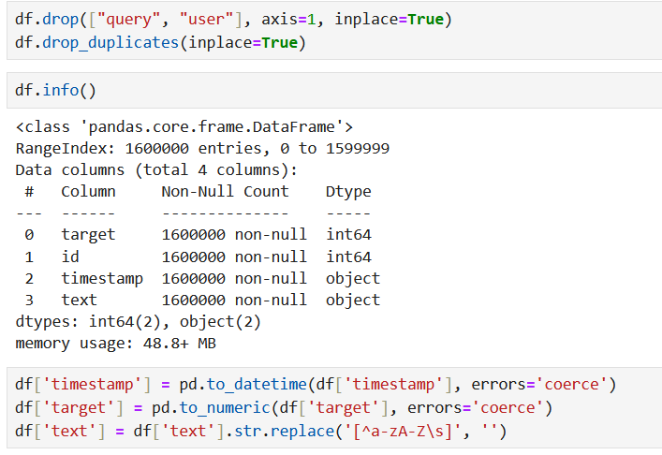

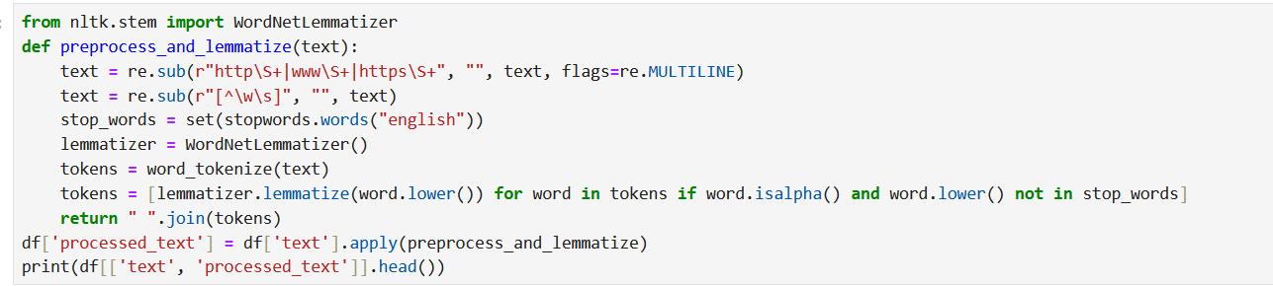

**Feature Engineering:**

Used TF-IDF vectorization to convert tweet text into numerical features.

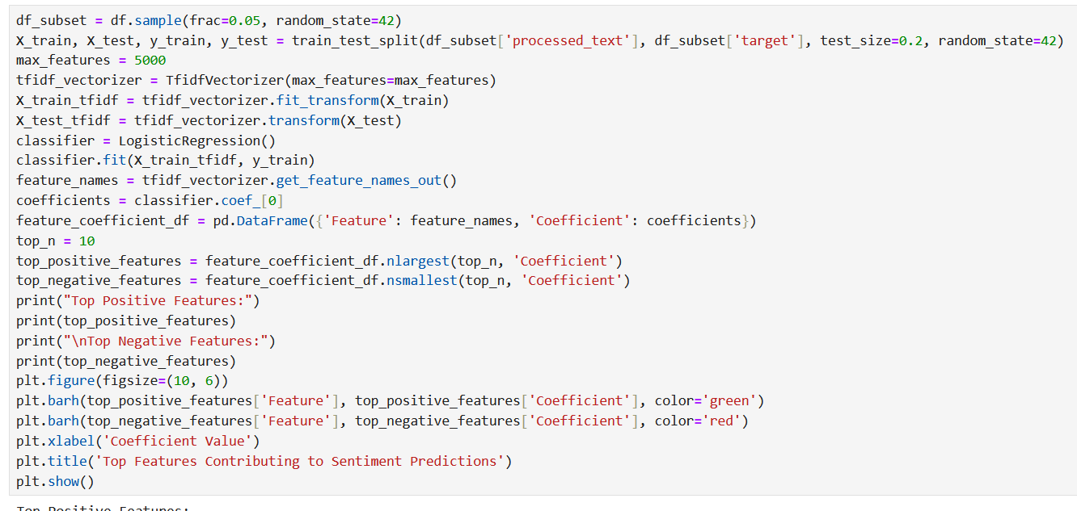Explored the top positive and negative features contributing to sentiment predictions.

**Model Implementation:**

Trained a Logistic Regression model on a subset of the dataset.

Evaluated model performance using accuracy and F1 score.

Visualized the top features contributing to sentiment predictions.

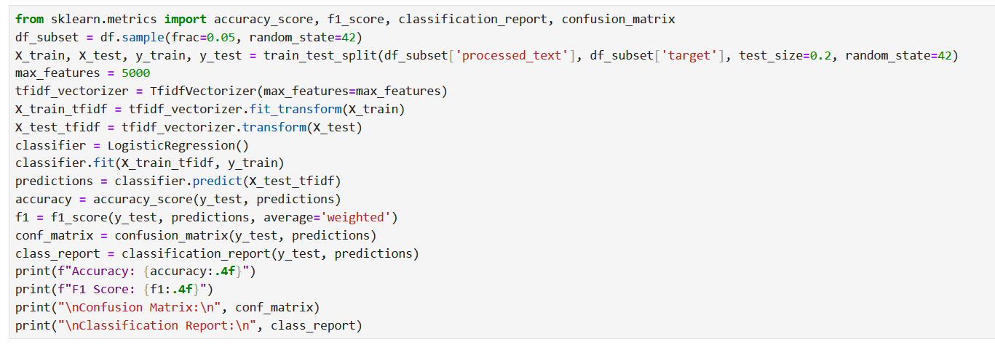

**Analysis Findings:**

Explored the balance of sentiment classes.

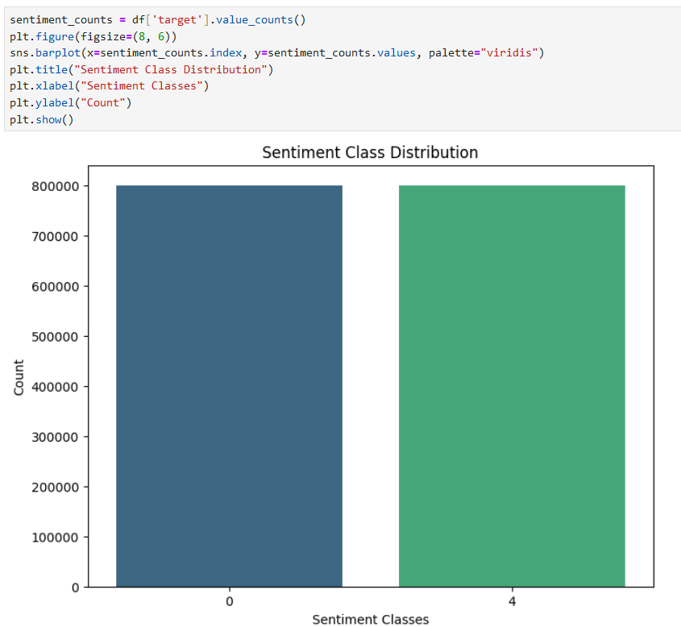

Analyzed the frequency of words in tweets to identify common terms and themes.

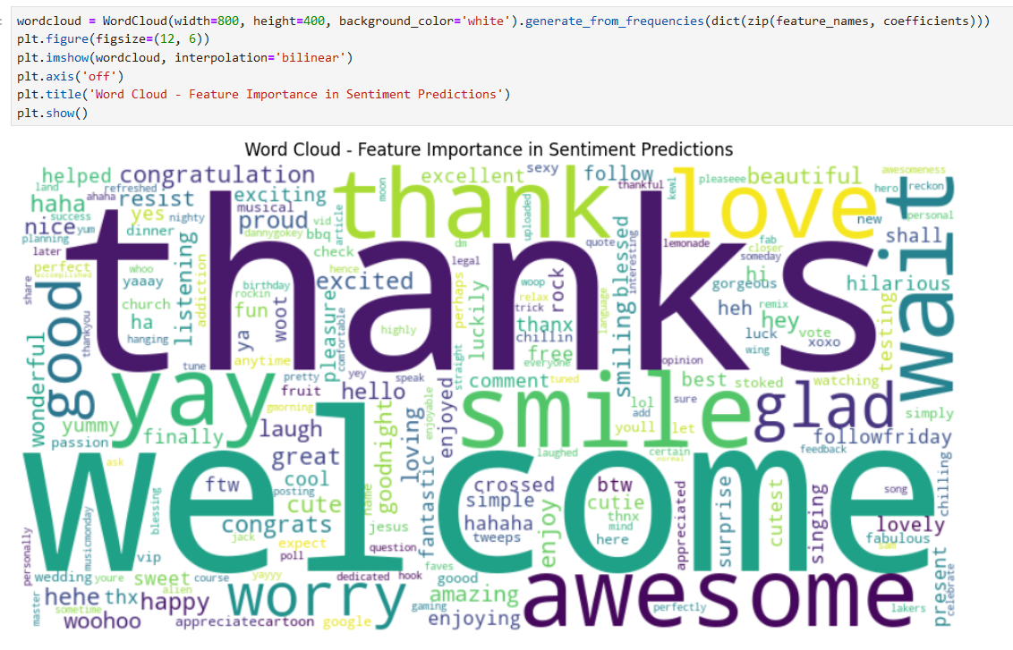

Explored how sentiment varies over time by analyzing tweet timestamps.

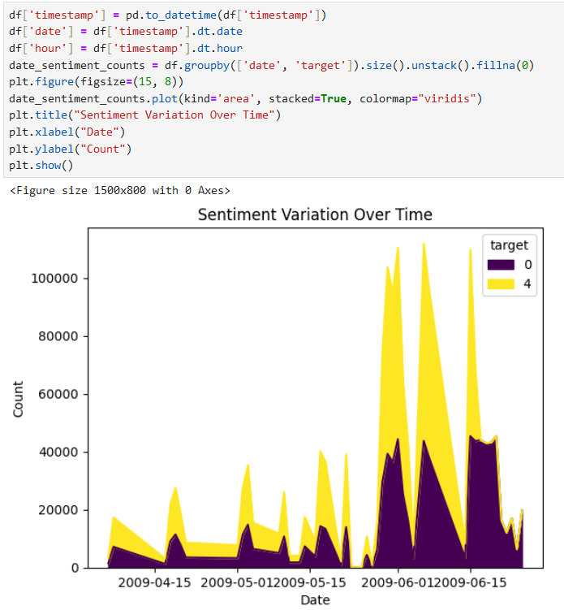

Identified patterns, peaks, or trends in sentiment within specific time frames.

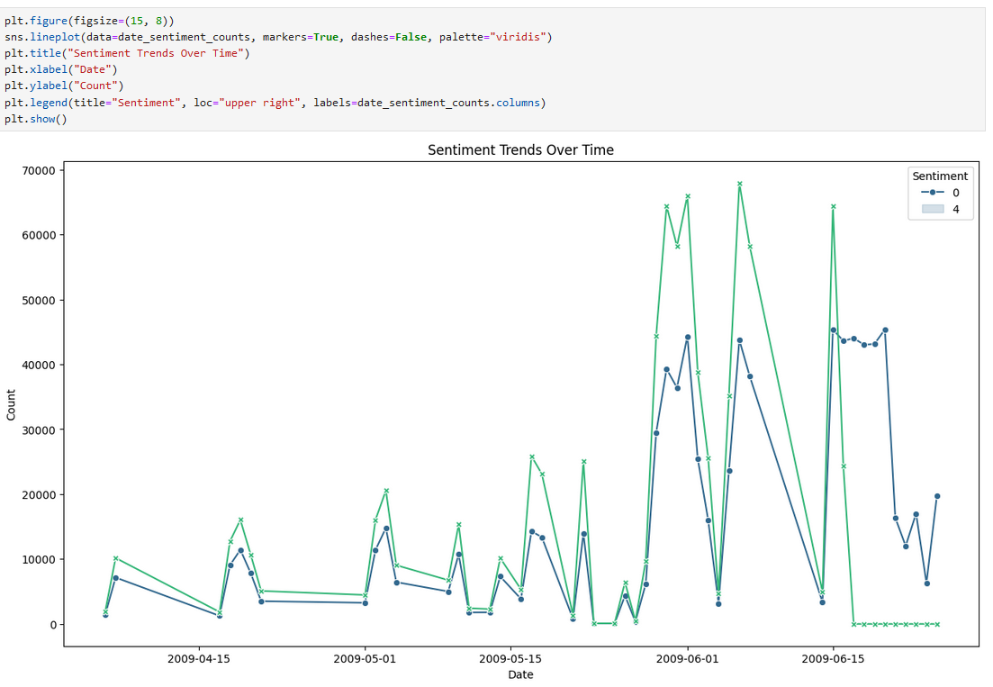

Here are some key insights gained from the Twitter Sentiment Analysis project:

**Sentiment Distribution:**

The sentiment distribution in the dataset is relatively balanced, with approximately equal proportions of positive, negative, and neutral sentiments. This suggests that the dataset provides a fair representation of various sentiment classes.

**Common Terms and Themes:**

The analysis of common words in tweets revealed prevalent terms and themes.

**Temporal Analysis:**

By exploring sentiment trends over time, we identified fluctuations and patterns in sentiment within specific time frames. This temporal analysis helps understand how sentiments evolve in response to events, seasons, or trends.

**Model Performance:**

The Logistic Regression model achieved a notable accuracy and F1 score, indicating its effectiveness in predicting tweet sentiments. This demonstrates the feasibility of using machine learning techniques for sentiment analysis tasks.

**Feature Importance:**

Analyzing feature importance revealed key words and phrases contributing to sentiment predictions. Understanding these influential features can provide valuable insights into the factors driving public sentiment.

**Overall Insights:**

Through comprehensive analysis, we gained insights into public sentiments, trends, and themes shared on Twitter. These insights can inform decision-making processes, marketing strategies, or public opinion understanding in various domains.

Overall, the Twitter Sentiment Analysis project provided valuable insights into the dynamics of public sentiment on Twitter, empowering stakeholders with actionable insights for informed decision-making.

Based on the sentiment trends observed in the Twitter Sentiment Analysis project, here are some actionable recommendations and suggestions:

**Leverage Positive Sentiment Peaks:**

During periods of high positive sentiment, capitalize on the positive buzz by amplifying marketing efforts, launching promotions, or introducing new products/services. Engage with customers who express positive sentiments to reinforce brand loyalty and advocacy.

**Address Negative Sentiment Proactively:**

Promptly address negative sentiment trends by identifying the root causes of dissatisfaction and taking corrective actions. Implement strategies such as proactive customer outreach, issue resolution, and transparent communication to mitigate negative sentiment and rebuild trust.

**Adapt Marketing Strategies:**

Tailor marketing strategies and messaging based on sentiment trends to resonate with the prevailing mood of the audience. Adjust campaign messaging, tone, and imagery to align with positive sentiment peaks and avoid exacerbating negative sentiment.

**Engage with Neutral Sentiment Conversations:**

Engage with conversations characterized by neutral sentiment to foster relationships, gather feedback, and address customer inquiries. Use these interactions as opportunities to provide value, gather insights, and enhance brand perception.

**Monitor Competitor Sentiment:**

Monitor sentiment trends of competitors to identify emerging threats or opportunities. Analyze competitor sentiment to benchmark performance, identify gaps, and inform strategic decision-making, including product positioning and differentiation strategies.

**Investigate Root Causes of Negative Sentiment:**

Conduct thorough analyses to identify the underlying reasons behind negative sentiment trends. Utilize sentiment analysis in conjunction with qualitative research methods to gain deeper insights into customer pain points, product issues, or service deficiencies.

**Continuous Monitoring and Analysis:**

Implement robust monitoring systems to continuously track sentiment trends in real-time. Leverage advanced analytics tools and sentiment analysis techniques to detect shifts in sentiment, predict emerging trends, and proactively respond to changing customer perceptions.

**Employee Training and Customer Service Enhancement:**

Invest in employee training programs focused on empathy, active listening, and effective communication to handle customer interactions during periods of heightened sentiment. Strengthen customer service capabilities, streamline processes, and empower frontline employees to deliver exceptional customer experiences.

By incorporating these recommendations into business strategies and operational processes, organizations can harness the insights gleaned from sentiment analysis to enhance brand reputation, improve customer engagement, and drive sustainable growth in a dynamic and competitive marketplace.